FIELD ARTILLERY SURVEYOR
MOS 13S SKILL LEVEL 3
FA6031-A
SURVEY PLANNING
US Army Field Artillery School
Fort Sill, Oklahoma
Three Credit Hours
GENERAL
This subcourse is designed to train the skills necessary for performing tasks related to survey planning and selection of observation posts. This subcourse is presented in four lessons, each lesson corresponding to a terminal objective supporting the following soldier’s manual tasks:
LESSON 1: The Planning Process
TASK NO: 061-302-4301
TASK: Plan a Survey Operation
CONDITIONS: Given a mission order, a briefing on the overall operation, a standard 1:50,000-scale map of the area, a coordinate scale, a protractor (mils), a compass, binoculars, trig list data of the area, and a vehicle with a radio and a driver.
STANDARDS: Plan a survey operation that provides survey control at critical locations within the time and accuracy specified in the survey mission order.
LESSON 2: Plan a Traverse and Triangulation Scheme
TASK NO: 061-302-3201
TASK: Plan a Traverse Scheme
CONDITIONS: Given a Field Manual (FM) 6-2, a survey mission order, standard 1:50,000-scale military map(s) and trig lists of the area, a coordinate scale, a plotting scale, a protractor (mils), a compass, binoculars, and a vehicle with a radio and driver.
STANDARDS: Plan a traverse scheme that provides survey control at critical locations within time and accuracy standards required in the survey order.
TASK NO: 061-302-3202
TASK: Plan a Triangulation Scheme
CONDITIONS: Given a Field Manual (FM) 6-2, a survey mission order, standard 1:50,000-scale military maps and trig lists of the area, a coordinate scale, a plotting scale, a protractor (mils), a compass, binoculars, and a vehicle with a radio and driver.
STANDARDS: Plan a triangulation or intersection scheme that provides survey control at critical locations within the time and accuracy specified in the survey order.
LESSON 3: Plan a Three-point Resection and an Astronomic Observation
TASK NO: 061-302-3203
TASK: Plan a Three-point Resection
CONDITIONS: Given a Field Manual (FM) 6-2, a survey mission order, standard 1:50,000-scale military maps and trig lists of the area, a coordinate scale, a plotting scale, a protractor (mils), a compass, binoculars, and a vehicle with a radio and driver.

STANDARDS: Plan a three-point resection that provides survey control at critical locations within the time and accuracy specified in the survey order.

TASK NO: 061-302-5006

TASK: Plan an Astronomic Observation

CONDITIONS: Given a survey mission order, local date and time of observation, time accurate to the nearest second, temperature accurate to +/- 5 degrees, standard 1:50,000-scale military map of the area, Field Manual (FM) 6-300, a world star chart, a coordinate scale, a protractor (mils), starfinder and identifier, a power source, a Forward Entry Device (FED) Met/Survey (MSR) or Handheld Terminal Unit (HTU), Department of the Army (DA) Form 7362-R.

STANDARDS: Plan an astronomic observation that provides an azimuth within the time and accuracy specified in the survey mission order.
LESSON 4: Select Positions for Observation Posts and Plan a Simultaneous Observation

TASK NO: 061-302-3202

TASK: Plan an Intersection

CONDITIONS: Given a Field Manual (FM) 6-2, a survey mission order, standard 1:50,000-scale military maps and trig lists of the area, a coordinate scale, a plotting scale, a protractor (mils), a compass, binoculars, and a vehicle with a radio and driver.

STANDARDS: Plan a triangulation or intersection scheme that provides survey control at critical locations within the time and accuracy specified in the survey order.

TASK NO: 061-302-5006

TASK: Plan an Astronomic Observation

CONDITIONS: Given a survey mission order, local date and time of observation, time accurate to the nearest second, temperature accurate to +/- 5 degrees, standard 1:50,000-scale military map of the area, Field Manual (FM) 6-300, a world star chart, a coordinate scale, a protractor (mils), starfinder and identifier, a power source, a Forward Entry Device (FED) Met/Survey (MSR) or Handheld Terminal Unit (HTU), Department of the Army (DA) Form 7362-R.

STANDARDS: Plan an astronomic observation that provides an azimuth within the time and accuracy specified in the survey mission order.

TABLE OF CONTENTS
Page

TABLE OF CONTENTS 4
ADMINISTRATION INSTRUCTIONS 7
Lesson 1: The Planning Process 8
Introduction 8
Conduct of Planning 8
Factors Affecting Survey Planning 11
Essentials of a Good Survey Plan 13
Steps in Survey Planning 13
Survey Order 15
Methods of Survey 19
Time, Terrain, and Equipment 22
Summary 22
Lesson 1 Practical Exercise 23
Lesson 2: Plan a Traverse and Triangulation Scheme 26
Traverse 26
Triangulation 28
Situation One 29
Situation Two 33
Specification and Techniques 37
Summary 39
Lesson 2 Practical Exercise 41
Lesson 3: Plan a Three-point Resection and an Astronomic Observation 44
Three-point Resection 44
Situation Three 45
Astronomic Observation 47
Methods of Determining Astronomic Azimuth 48
Selection of Method 49
Choice of Method 50
Summary 51
Lesson 3 Practical Exercise 53
Lesson 4: Select Positions for Observation Posts and Plan a Simultaneous Observation 56
Target Area Base 56
Mission 57
Map Reconnaissance 57
Ground Reconnaissance 58
Sketch 59
Survey Order 59
Simultaneous Observation 59
Summary 63
Lesson 4 Practical Exercise 64
Examination

ADMINISTRATION INSTRUCTIONS
Subcourse Content.
This subcourse contains four lessons, each related to one or more survey tasks. An introduction presents an overall view of the subject. Each lesson then explains how to perform each task or tasks as it pertains to the artillery surveyor.
Supplementary Requirements.
The following subcourses should be completed before taking this subcourse:
FA 6001 Introduction to Field Artillery Survey
FA 6002 Basic Mathematics for Field Artillery
FA 6003 Logarithms
FA 6004 Field Artillery Survey Taping and Field Notes
FA 6005 M2 Aiming Circle
FA 6006 Theodolites
FA 6007 Azimuth Measuring Instruments
FA 6008 Distance Measuring Equipment
FA 6009 Astronomic Observation
FA 6022 Survey Computations
FA 6023 Astronomic Survey Computations
Prerequisites listed are based upon skill progression solely within the correspondence course curricula. Therefore, enrollees who have acquired this included knowledge from other sources may not need to complete listed pre- requisite courses. If you are unable to complete this subcourse because of lack of prerequisite knowledge, request the prerequisite subcourse(s) from Cdr, USATSC, ATTN: IPD, Fort Eustis, BA 23604.

Materials Needed. Request adjunctive material from: Army Correspondence Course Program (ACCP)
US Army Training Support Center
Newport News, VA, 23628-0001
Telephone: (757) 878-3322/2127, AUTOVON: 826-3322/2127

Coordinate square; protractor; map, Poland, ZARKI, 1:50,000, sheet 3019 111, series M753 ; pencil; paper; and straightedge. (The last three items must be furnished by the student.)

LESSON 1
THE PLANNING PROCESS
OBJECTIVE
Upon completion of this lesson you will be able to understand and explain procedures of planning survey operations.
REFERENCES
This subcourse is based on FM 6-2 and other materials approved for US Army field artillery instruction; however, development and progress render the text continually subject to change. Therefore, base your examination answers on material presented in this text rather than on individual or unit experience.
1. INTRODUCTION. Changing battlefield concepts have made it necessary for all survey officers and NCOs to adjust their thinking and modify techniques in order to provide timely survey for field artillery. Today's artillery survey must be fast, flexible, dynamic, and timely. On the mobile battlefield, the numerous targets, target locating devices, and weapons must be located with respect to common grid and direction in order to increase the probability of a first-round hit. To accomplish this, the survey officer/NCO must be proficient in planning and executing all survey methods.
2. CONDUCT OF PLANNNING. Surveys are planned to ensure that all required control is provided in the correct place and at the time required. The plan distributes work evenly among teams and eliminates duplicate work. Planning is based on meeting as many survey requirements as possible under the given conditions and always providing the best available survey control to using units. Direction is the most important element of survey control. Therefore, when time is critical, the plan must reflect the requirement to rapidly extend direction throughout the area of operation and later extend coordinates and height.
a. Survey planning is conducted at all echelons at the same time. Provisions should be made to link together all surveys conducted in the area. Normally, the surveyors of div arty HHB provide survey control points to all assigned and attached battalions or separate batteries. Thus, they tie together the surveys of the division firing and locating elements. The Target Acquisition Battery (TAB) and battalion surveyors survey their organic and attached elements and help other units as directed. The degree of accuracy, speed of execution, and priority of work are given in the commander's guidance or are set by the S3 from the commander's guidance.
b. Artillery units at all levels start survey operations before occupation of position. They do not wait for higher-echelon survey control to be established in the area. Firing and target-locating units must work from the best available data and improve the data as higher-order survey becomes available.
c. Fourth-order survey sections are organic to the div arty HHB and TAB to provide survey control for assigned and attached units of the division. Each artillery battalion has an organic fifth-order survey section. These sections are organized into survey teams and equipped according to the modification tables of organization and equipment (MTOE) for the unit. The concept of employment of these sections is based on the guidelines below.
(1) Div arty. Provide all organic, attached, and reinforcing artillery battalions, Target Acquisition (TA) assets, and separate batteries with common direction, coordinates, and height.
(2) TAB. Provide common direction, coordinates, and height for the TA assets of the battery. Provide SCPs for other units as directed by the TAB commander.
(3) Battalion. Provide common direction coordinates, and height for all firing batteries and targeting devices that are assigned or attached to or reinforcing the battalion and mortars.
d. For the purpose of planning a survey, installations may be separated into groups according to the accuracy of survey required. Requirements and position considerations are shown in Figure 1.
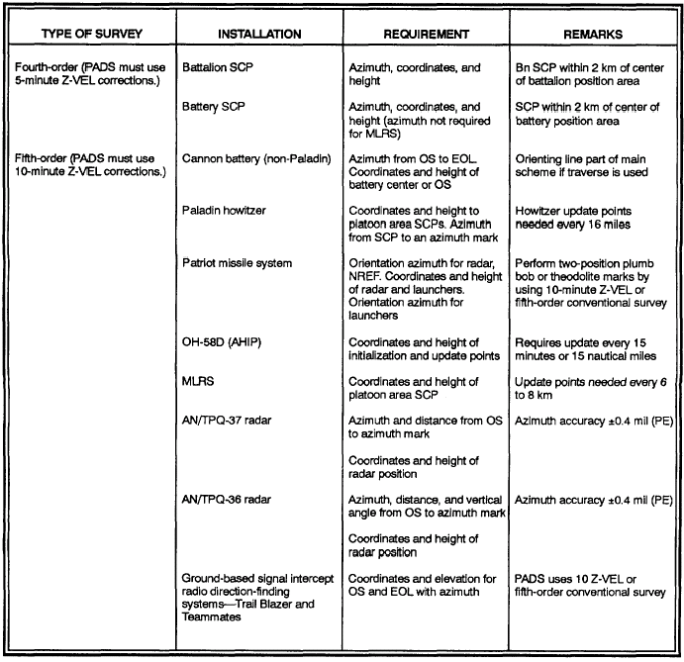

Figure 1. Survey Installations
(1) Fourth order. Fourth-order survey control is required at firing battalion and separate battery SCPs.
(2) Fifth order. Fifth-order survey control is required by firing and target-locating installations. Some installations require 0.4-mil or 0.5-mil accuracy for direction. Care must be used in selecting a method to establish direction for these installations. The requirements for CEWI sites should be addressed by local SOP or coordinated by the div arty survey officer.
(3) Hasty survey. All firing and target-locating elements requiring survey must be able to use hasty survey techniques to provide the best available survey control rapidly. The hasty survey techniques
preferred for a particular system are covered in the applicable field manual. For example, FM 3-09.50 (FM 6-50) prescribes hasty survey techniques for FA cannon batteries.
3. FACTORS AFFECTING SURVEY PLANNING. In formulating the plans by which the survey mission is to be accomplished, the survey planner must consider the factors of mission, enemy, terrain and weather, troops, time available, and civilian personnel (METT-TC). The factors of METT-TC cannot be considered independently because each is related to the other.
a. Tactical Situation. The enemy and friendly situations have a strong influence on survey operations, since the disposition of troops may interfere with or restrict movement of survey personnel and their equipment. Restrictions on communications can greatly reduce the effectiveness of survey parties (radio silence). The capabilities of the enemy to interfere with survey operations by denying the use of terrain or routes are of prime importance. During periods when survey operations are restricted, the commander could give priority of survey to those units supporting the main attack.
b. Mission. The tactical mission of the unit determines the time available, the area to be surveyed, and the accuracy and priority of the survey effort. It is the basis of the survey mission and determines the influence of all other factors on the survey.
c. Number of Installations. The number and location of field artillery installations must be considered primarily with respect to time and personnel available. The survey operation necessary to locate a small number of widely scattered installations will often require more time and/or personnel than would be required for a large number of closely grouped installations. In the survey plan, the survey tasks should be so allocated that the various parties executing the survey will complete their tasks in the most expeditious manner.
d. Starting Survey Control. Starting control for field artillery survey may be obtained from a variety of sources. This control may be established by a higher or adjacent headquarters survey section, requested from a survey information center, or determined from existing trig lists. Survey operations are concurrent at all echelons; and when starting control is not provided, it must be assumed and the necessary survey operations initiated immediately. More extensive survey operations are required in areas where limited survey control exists. In areas where survey control is dense, careful planning can do much to expedite the operation.
e. Personnel. The status of survey personnel available to perform the mission greatly affects the plan. The status of training determines the methods available to perform survey.
f. Enemy. The enemy situation has a strong influence on survey operations, since the disposition of troops may interfere with or restrict the movement of survey personnel and their equipment. Restrictions on communications, such as radio silence and enemy jamming, can greatly reduce the effectiveness of survey teams. The ability of the enemy to interfere with survey operations by denying use of terrain or routes is of prime importance. When survey operations are restricted, the commander should give priority of survey to those units supporting the main attack. FA surveyors must be able to implement suppressive fire immediately if they receive enemy fire. Terrain and cover must be used as much as possible. Unit SOP should provide for actions to be taken by survey teams that came under fire.
g. Time. The time available to complete the survey operation is the most critical factor in planning. Survey supervisors should use the survey techniques necessary to provide the best survey data within the prescribed time. A trade-off between accuracy and time may have to be made, depending on the tactical situation.
h. Terrain. The type of terrain over which survey control must be extended is a primary factor in determining the method of survey to be used. The survey officer/NCO should be so familiar with the effects of various types of terrain on survey operations that he can promptly and properly advise his commander on the time and personnel requirements for survey operations.
i. Weather. Adverse weather will greatly reduce the capability of survey parties. Fog, rain, snow, or dust can reduce visibility to the extent that observations through an optical instrument are impossible. Poor visibility requires shorter distances between stations, necessitating more angle turning. During periods of poor visibility, the commander may choose to put his survey effort on accurately locating his radar, so that it can locate his firing units. In this situation, the north seeking gyro would be used to establish common direction. Extreme heat or cold can also reduce survey party efficiency and increase the time needed to complete the survey.
j. Priority. Any priority for survey control established by the commander or indicated by the tactical situation must be considered in developing the survey plan. The priority of work may affect the order in which the plan is executed or the type of survey performed.
4. ESSENTIALS OF A GOOD SURVEY PLAN. In formulating the survey plan, the survey officer/NCO must remember and strive to meet certain essentials. The survey plan must—
a. Be Simple. All party personnel must understand the plan.
b. Be Timely. The plan must be capable of execution in the time allotted.
c. Be Flexible. The plan must be capable of being changed if the situation warrants a change.
d. Be Adaptable. The plan must be adaptable to the terrain, situation, personnel available, weather, etc.
e. Provide for Checks. Whenever possible, the plan must provide for checks; i.e., closed surveys, alternate bases, and checks made by each member of the party.
f. Provide Required Control. The plan must provide survey control within the required accuracy to all installations that require survey.
5. STEPS IN SURVEY PLANNING. The steps in planning a survey generally follow the normal small unit troop-leading steps. They are the procedures by which a commander issues instructions to his subordinates so that he can accomplish his mission. The lower the echelon, the more simple, direct, and rapid the process. Once the battle starts, orders and responses must be fast, effective, and simple. This requires teamwork. Troop-leading steps should be an instructive and automatic way of thinking for section leaders and commanders. Without detailed instructions, commanders must turn a mission order into actions to support the plan of the next higher commander. Elaborate troop-leading procedures are useless if they slow the response of the force. An explanation of the troop-leading steps follows.
- Receive the Mission. Leaders receive a mission in either an oral or written OPORD or fragmentary order (FRAGO). Upon receiving the order, the leader analyzes the mission and plans the use of available time. The FSCOORD or S3 gives the survey officer a mission. It may consist of general areas to be surveyed or specific locations for battalion SCPs, platoon area SCPs, molar positions, and such.

- Issue a Warning Order. The leader issues a warning order that gives his subordinates the mission and the time it starts. He issues it early enough for the section to plan and prepare. Normally, warning orders are issued through the chain of command. In that way, all personnel are kept informed of what they must do and why they must do it. The warning order should include the location of a nearby SCP or prominent landmark. Preoperational checks of vehicles and equipment are completed.
c. Make a Tentative Plan. The first step in planning is to gather information on the area, the enemy situation, and any usable known control. A map reconnaissance is performed to tentatively determine a method of survey.
(1) Gathering information. From the unit commander's briefing, the survey officer/NCO gathers vital information that will influence the planning of his survey. This information should be pertinent to—
(a) The situation. Include the mission of the units, status of registration, time available, zone of fires, friendly positions, firing charts to be used, etc.
(b) Points to be surveyed. Include the designation and location of points to be surveyed, position areas, observation posts, registration points, and radar sites, as required.
(c) Restrictions. Include restrictions on mode of travel, routes, communications, minefields, and contaminated areas.
(2) Map reconnaissance. After attending the commander's briefing and issuing a warning order to alert his personnel, the survey officer/NCO performs a thorough map reconnaissance by use of any suitable map or map substitute. In making the map reconnaissance, the survey officer/NCO follows a specific procedure.
(a) Map-spots installations. He plots on the map those installations requiring survey control and the known control.
(b) Selects tentative plan. He considers all the factors that affect survey, makes a choice of methods, and arrives at a tentative plan.
(c) Considers time. He determines if the survey mission can be accomplished in the allotted time. If not, he makes appropriate recommendations to the commander. He may recommend that additional personnel be made available, that the time allotted for survey be increased, and/or that the location of certain installations be delayed.
(d) Determines critical areas. He determines the most critical areas requiring detailed reconnaissance.
d. Start Necessary Movement. The survey officer/NCO must now make good use of time available so that the section will be in the area to be surveyed at the required time. If the section must move a long distance, it should be set in motion immediately.
e. Reconnoiter. After completion of the map reconnaissance, the survey officer/NCO must make a ground reconnaissance as detailed as time permits. The tentative plan selected during the map study is modified as required by the terrain. Particular emphasis is placed on reconnoitering areas that may be critical. Where necessary, indications are made at points where tentative plans may require revisions or close coordination. A scale sketch (1:25,000) of the survey is an easy way to summarize the ground reconnaissance. Since a PADS team can provide survey data as it reconnoiters, greater emphases must be placed on efficiency of movement through the area.
f. Complete the Plan. Reconnaissance may or may not change the tentative plan, but it will certainly add detail. Modify the plan, if necessary.
g. Issue the Order. A verbal order is issued, if possible, from a vantage point overlooking the area to be surveyed. It is a standard five-paragraph order format.
h. Supervise. A leader must continually supervise the survey operations and make changes, if required.
NOTE. | Troop-leading steps and their order are not rigid. Change them to fit the mission and situation. Often, some steps are taken at the same time, while others are considered continuously throughout the operation. When there is a lack of time, certain steps may be left out.
6. SURVEY ORDER. The survey order contains detailed instructions to each survey team not covered by local SOP. It gives general information needed for the efficient accomplishment of the survey mission. The survey order is written or issued orally. It generally follows the same sequence as the OPORD. Often, because of the tactical situation and wide dispersal of units, parts of this order may be issued by radio or wire or both.
a. The format for a five-paragraph survey order is shown below.
- Situation. Items in this paragraph are addressed only if they have bearing on the execution of the survey mission.
    - Enemy Forces. This subparagraph contains information from the S2 on enemy forces that may affect the survey mission.
    - Friendly Forces. This subparagraph contains information on higher, adjacent, and supporting units that may affect the survey mission.
    - Attachments and Detachments. This subparagraph lists sections attached or detached for a particular mission, such as an infantry squad for security.
- Mission. This paragraph is a clear, concise statement of the task to be done by the section. It includes those task specified by the S3. Also, it may include implied tasks determined by the survey officer from his mission analysis. Normally, it describes who, what, when, where, and as appropriate, why. This paragraph has no subparagraphs.
- Execution.
    - Concept of Operation. This subparagraph briefly describes the survey methods to be used. It answers the question, generally, how will the survey be done?
(The intermediate subparagraphs of paragraph 3 [b, c, d, e, and so forth] are specific missions of subordinate survey sections or teams. These missions tell the subordinate leader what he must do but not how he must do it [unless rigid centralized control must be maintained]. The mission of each subordinate team is addressed in its own paragraph, which contains instructions for that team only.)
(f) Coordinating Instructions. The last subparagraph contains instructions common to two or more units. These instructions are designed to keep the subordinate units working together. Instructions such as primary methods of determining azimuths and distances are appropriate as coordinating instructions.
- Service Support. This paragraph lists those logistical considerations that may concern the surveyors. It lists food, ammunition, POL, location of corpsmen and aid stations, handling of enemy prisoners of war, and nonorganic transportation. These considerations are addressed only as they affect the particular survey. Local SOP items need not be addressed.
- Command and Signal
    - Command. This subparagraph gives the locations of the CP, survey officer, chief surveyor and team chiefs
    - Signal. This subparagraph lists nonstandard hand-and-arm signals, pyrotechnics, radio frequencies, call signs, and electronic counter-countermeasures (ECCM).
b. FRAGOs include the information in paragraphs 2 and 3 of the survey order and anything else that has changed since the last order.
NOTE: See Figure 2 for sample survey order.

1. SITUATION:

a. Enemy forces. The Aggressor Forces, a Heavy Mechanized Inf Div, has withdrawn north of east-west grid line 46 (not on map sheet) and set up a defensive position.

b. Friendly forces. The 20th Inf Div, a part of 10th Corps, is engaged in tactical operations to drive the aggressor forces from the friendly territory. The 1st Bde, 20th Inf Div, is employed in the center of the division's zone of operation and will lead the assault. The left boundary of the 1st Bde is highway 277/281, the right boundary is north-south grid line 68. The 2nd Bde, 20th Inf Div is employed on the right, and the 3rd Bde, 20th Inf Div is employed on the left. The 1st Bn, 45th FA, a part of the 20th Inf Div Arty, consist of HHB and three two platoon firing batteries-A, B, and C. The battalion is in direct support of the 1st Bde. The battalion is currently located at grid 575305. All elements of the 1st Bn, 45th FA, are at full strength and the personnel are well trained.

c. Attachments and Detachments. A 4.2 Mortar Platoon and one AN/TPQ-36 Radar Section are attached to the 1st Bn, 45th FA.

2. MISSION: The survey platoon will extend survey control to the batteries and the attached radar and mortar platoon. The new positions are: A Btry, grid 585412. B Btry, grid 617409. C Btry, grid 655418. AN/TPQ-36 Radar, grid 602406. Mortar Platoon grid 622438. Survey operations will start no later than (NLT) 1400 hours. All installations must be on a common grid NLT 1800 hours. The starting SCP is station NAA 4 in grid square 636390. The azimuth mark is station Caddo 2 in grid square 6136. The closing SCP is station BCA 2 in grid square 5839. Alternate and supplementary position requirements, and future plans will be announced later.

3. EXECUTION:

a. Concept of Operation. The survey mission will be accomplished by PADS, and conventional survey employing the traverse method of survey.

b. The PADS team will survey C Btry, the mortar platoon, and A Btry and close on station BCA 2.

c. The conventional team will survey B Btry and the radar and close on station BCA 2.

d. Coordinating Instruction. The PADS team will depart this location NLT to initialize the system prior to the conventional team arriving at the start point. The team will establish a closing azimuth for the conventional team at station BCA 2.

4. SERVICE SUPPORT: MREs will be issued for lunch on __ . All other support will be located near battery command post.

5. COMMAND AND SIGNAL:

a. Command. Battery command post will be located at grid 621397. The survey officer and chief surveyor are mobil.

b. Signal. Use FM secure voice.

Figure 2. Survey Order
7. METHODS OF SURVEY. In addition to being able to properly evaluate the factors that will affect the survey, the survey officer/NCO must have knowledge of the methods of survey that might be used and the advantages and disadvantages of each. The method chosen to provide survey control depends on the factors of METT-TC. PADS survey supplemented by conventional methods is the primary means of executing the survey order.
a. PADS Surveys. The main advantage of the PADS over conventional methods is its speed. Disadvantages of the PADS include the following:
- Reliance on the availability of survey control.
- Mode and route of travel.
- Restrictions on mission time and radial distance from the update point.
These are the main considerations in planning PADS operations. The time and distance factors used for planning PADS missions are shown in Figures 3 and 4.

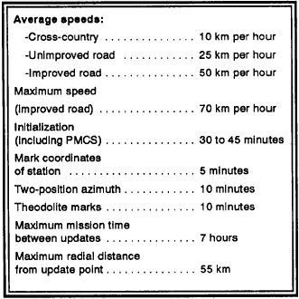

Figure 3. Time and Distance Factors-PADS Mission
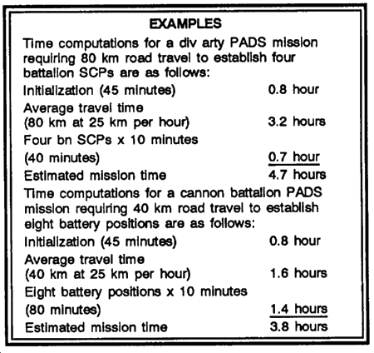

Figure 4. Example PADS Mission

b. Conventional Survey Methods. Conventional methods of survey may be used exclusively to extend or establish survey control if the PADS is not available. When the PADS is available, conventional methods are used to supplement PADS operations. Conventional teams provide update points for the PADS teams as required. This reduces the need to backtrack to close the PADS survey. Required installations along the route taken by conventional teams in establishing update points are surveyed to save time. Simultaneous observation is used to quickly establish direction before PADS teams arrive at installations. The conventional survey team gives the survey planner flexibility. This allows the plan to be tailored to fit the factors of METT-TC and allows sustained PADS operation by rotation of survey personnel. Conventional survey methods are as follows:
- Traverse.
- Triangulation.
- Intersection.
- Resection.
(1) Traverse. Traverse is the most suitable conventional method for most survey operations. It is a rapid and flexible means of extending control. Traverse does not require as much reconnaissance as triangulation and is extremely easy to control in the field. Traverse is ideally suited for survey in gently rolling or flat terrain or for extending control along roads and trails. For planning purposes, a well-trained traverse team can extend control over open and gently rolling or flat terrain at a rate of about 2 km per hour with the SEDME-MR or 1 km per hour with a 30-meter steel tape. The use of offset legs to locate radar positions and other points can reduce the time required for the traverse. Offset traverse legs are not used to carry control, and an error made during the offset leg fieldwork will not affect traverse closure. Therefore, the fieldwork must be carefully checked.

(2) Triangulation. Triangulation is a means of extending control over long distances. It is ideally suited for survey in difficult terrain and for crossing obstacles. The primary disadvantage of triangulation is the amount of time required for reconnaissance. For planning purposes, triangulation requires about 30 minutes per station plus time for reconnaissance and travel between stations. Triangulation schemes are not as flexible as traverse schemes, since all stations in a triangle must be intervisible. Reconnaissance for triangulation generally requires as much time as the fieldwork, especially in extensive triangulation schemes. If the distance-measuring equipment is operational, traverse is preferred because it requires less time and fewer personnel.

(3) Intersection. Intersection is a method of triangulation in which only two angles in a triangle are measured. It is used to locate critical points, to establish update points for the PADS, and to survey firing and target-locating elements. When control is extended from a point established by intersection, the survey must be closed on another known point. The only exception to this is when intersection is used to locate Observation Posts (OP1 and OP2 of the target area base).

(4) Resection. Resection is a method of obtaining control from distant points of known control that can be seen but not occupied. Resection is used to--
  - Locate firing and target-locating elements.
  - Establish update points for the PADS.
  - Locate OP1 and OP2 of the target area base.
  - Close a survey.
  - Check a location established by some other method of survey.
If a point located by resection is used to extend control, the survey must be closed on another known point. The only exception to this is when resection is used to locate OP1 and OP2 of the target area base.

8. TIME, TERRAIN, AND EQUIPMENT. Any one or a combination of these elements will play a major role in determining the method of survey to employ. Figure 5 illustrates what method is best in certain terrain and the rate of extension.
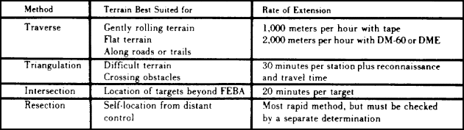
Figure 5. Terrain and rate of extension
9. SUMMARY. Changing battlefield concepts have made it necessary for all survey officers and NCOs to adjust their thinking and modify techniques in order to provide timely survey for field artillery. The commander must analyze the mission, establish priorities, and issue necessary guidance to survey supervisors so that they can provide timely data. Before the survey officer/NCO can provide timely data, a survey plan must be developed. The survey officer/NCO must consider many factors in formulating the plan by which the survey mission is to be accomplished. The factors that affect survey planning cannot be considered independently, because each is related to the other. These factors are: tactical situation, mission, number of installations, starting survey control, training personnel, time, terrain, weather, and priority. In addition to being able to properly evaluate the factors that will affect the survey, the survey officer/NCO must have knowledge of the methods of survey that might be used and the advantages or disadvantages of each

LESSON 1
PRACTICE EXERCISE
Top of Form
Instructions | The following items will test your understanding of the material covered in this lesson. There is only one correct answer for each item. When you have completed the exercise, check your answers with the answer key that follows. If you answer any item incorrectly, review that part of the lesson that contains the portion involved.
1. | Those factors that affect survey planning cannot be considered independently, because each is related to the other.
  A. True.
  B. False.

2. | The type of terrain over which survey control must be extended is a primary factor in determining the method of survey to be used.
  A. True.
  B. False.

3. | Today's artillery survey must be fast, dynamic, and timely.
  A. True.
  B. False.

4. | The survey plan must be simple, timely, flexible, adaptable, provide checks, and provide the required control.
  A. True.
  B. False.

5. | One of the disadvantages of using PADS is reliance on the availability of survey control.
  A. True.
  B. False.

6. | PADS survey is the primary means of executing the survey order.
  A. True.
  B. False.

ANSWER KEY
LESSON 1 PE
1. T (paragraph 3)
2. T (paragraph 3h)
3. T (paragraph 1)
4. T (paragraph 4)
5. T (paragraph 7a)
6. F (paragraph 7)

LESSON 2
PLAN A TRAVERSE AND TRIANGULATION SCHEME
OBJECTIVE
Upon completion of this lesson you will be able to plan a workable traverse and triangulation scheme.
10. Traverse. For most battalion survey operations, traverse is the most suitable method to use. It is a rapid and flexible means of extending control. Traverse does not require as much reconnaissance as triangulation and is extremely easy to control in the field. It is ideally suited for surveying in gently rolling or flat terrain or for extending control along roads and trails. For planning purposes, a well-trained traverse party using a 30-meter steel tape and taping techniques can extend control over open and gently rolling or flat terrain at a rate of approximately 1,000 meters per hour (2,000 meters per hour with the SEDME-MR). There are four types of traverse.
a. Traverse closed on second known point. The most preferred type of traverse is the traverse closed on a second known SCP. This type of traverse begins from a point of known coordinates, moves through the various required unknown points (traverse stations), and then terminates at a second point of known coordinates. The point on which the survey is closed must be a point established to an equal or higher order of accuracy than the traverse being conducted. This traverse provides checks on fieldwork, computations, and the starting coordinates and affords a basis for comparison to determine the accuracy of the work performed. Figure 6 shows a sample of a traverse closed on a second known point.
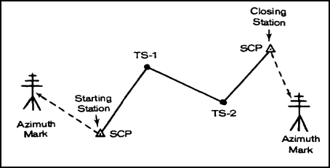
Figure 6. Traverse closed on second known point
b. Traverse closed on starting station. The next best method of traverse is a traverse closed on the starting station. This type of closed traverse begins at a point of known control, moves through the various required unknown points, and returns to the same point. This type of closed traverse is considered to be the second best and is used when both time for survey and limited survey control are considerations. It provides checks on fieldwork and computations and provides a basis for comparison to determine the accuracy of the work performed. This type of traverse does not provide a check on the accuracy of the starting data or ensure detection of any systematic errors. If a conventional survey team uses a PADS SCP, they must close on the same point because of the PADS circular error probable (CEP) and errors in determining assumed data. Figure 6 shows a sample of a traverse closed on the starting point.
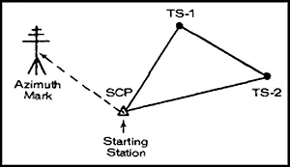
Figure 7. Traverse closed on starting point
c. Open traverse. An open traverse begins at a point of known coordinates and ends at a station whose relative position is not previously known. The open traverse is considered to be the least desirable type of traverse because it does not provide on check on the accuracy of the starting control, nor does it provide any check on the accuracy of the fieldwork. For this reason, traverses are never deliberately left open and are always closed as soon as possible. Open traverses are used only when time or the enemy situation does not permit a closure on a known point. Figure 8 shows a sample of an open traverse.

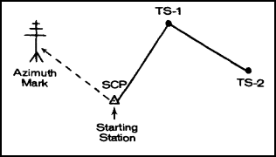
Figure 8. Open Traverse
d. Directional traverse. A directional traverse is a type of traverse extends only directional (azimuth) control. This type of traverse can be either open or closed. If open, the traverse should be closed at the earliest opportunity. It can be closed either on the starting azimuth or on another azimuth of equal or higher order accuracy. It also can be closed by comparison to an astronomic azimuth, gyroscopic azimuth, or a PADS azimuth. Since direction is the most critical element of FA survey and time is frequently an important consideration it is sometimes necessary at lower echelons to map-spot battery locations and extend direction only.
11. Triangulation. Triangulation is a means of extending control over long distances in relatively short periods of time. It is ideally suited for survey in difficult terrain and for crossing over obstacles that cannot be taped or measured electronically. The primary disadvantage of triangulation is the amount of time required for reconnaissance. For planning purposes, triangulation requires approximately 30 minutes per station plus time for reconnaissance and travel between stations. Flexibility in triangulation schemes more limited than in traverse schemes; therefore, reconnaissance for triangulation will generally require as much time as the fieldwork, especially in extensive triangulation schemes (see fig 9).
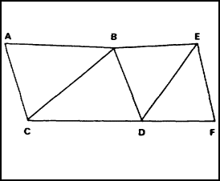
Figure 9. Triangulation scheme
12. SITUATION ONE. The survey officer/NCO has just returned from the commander's briefing on the next mission. He recorded the information pertinent to the situation such as:
- Mission of the unit.
- Status of the registration.
- Time available.
- Zones of fire.
- Friendly positions.
- Firing charts to be used.
- Communication restriction.
- Mode of travel and routes.
- Location of points to be surveyed. (You have a mission to establish two SCPs in the vicinity of grid coordinates 34UCB921183 and 34UCB912169 [ZARKI Map] for the 1-38 FA. It is now 0800, and you have until 2000 today to accomplish the mission. The SCPs must be established within 200 meters of the above coordinates).
NOTE. | The survey party has two taping teams and one theodolite. No electronic device is available for measuring distance. The survey must close with a comparative accuracy of 1:1,000 or better.
a. Perform a Map Reconnaissance. After the commander's briefing, the survey officer/NCO alerts the survey personnel and performs a map reconnaissance. In making a map reconnaissance, the survey officer/NCO uses the following procedures:
(1) Plots installations. He plots on the map those installations requiring survey control. He also plots the known survey control points in the area of operation (fig 10).
(2) Selects a tentative plan. He considers all factors that affect survey (Para 3), makes a choice of survey methods, and arrives at a tentative plan. In this example, he decides to run a traverse and close on a second known point. The terrain looks suitable for traverse, although some areas require a detailed ground reconnaissance. Plot the tentative plan on the map, and note the critical areas (fig 10). Note that the last distance in the traverse will be determined by trig-traverse.
NOTE. | Refer to the ZARKI map (enclosed with subcourse) to get a good view of the area. Do this with all survey planning in this subcourse. Figure 10 is a photographed portion of the ZARKI map, and some portions may be distorted.
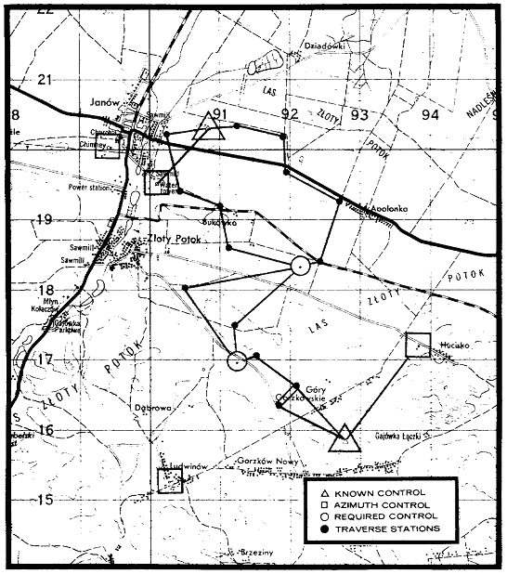
Figure 10. Known and proposed survey points
b. Perform Ground Reconnaissance. After completion of the map reconnaissance, the survey officer/NCO assembles the traverse party and briefs them on the plan. After the briefing, load personnel and equipment and depart for the known SCP where the traverse will start. Upon arrival at the starting point, instruct the instrument operator to set the instrument up over the survey station and point out the azimuth marker. The survey officer/NCO must make a ground reconnaissance as detailed as time permits The tentative plan selected during the map study is modified as required by terrain and other obstacles. Particular attention is placed on areas that may be critical (steep slopes and line of sight).
NOTE. | If time is critical, the ground reconnaissance can be done as the traverse proceeds.
c. Sketch. After or during the ground reconnaissance, a sketch must be drawn of the traverse scheme. The sketch must—
- Be drawn to scale.
- Contain a grid north index.
- Provide sufficient information to enable recovery or reconstruction of the fieldwork.
- Be recorded in the field notebook.
d. The Survey Order. Upon completion of the ground reconnaissance, the survey officer/NCO finalizes the plans (fig 11) and issues his orders. An example of a survey order is shown in FM 6-2, chapter 15.
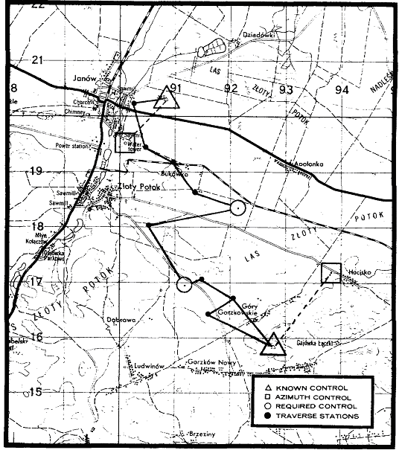
Figure 11. Survey Plan
13. SITUATION TWO. The survey officer/NCO has just returned from the commander's briefing on the next mission. He recorded the information pertinent to the situation such as:
- Mission of the unit.
- Status of registration.
- Time available.
- Zone of fire.
- Friendly positions.
- Firing charts to be used.
- Communication restrictions.
- Mode of travel and routes.
- Location of points to be surveyed. (You have a mission to establish two SCPs in the vicinity of grid coordinates 34UCB902145 and 34UCB921096 [ZARKI map] for the 25th Division Artillery. It is now 0800, and you have until 1200 tomorrow to complete the mission. The SCPs must be established within 200 meters of the above coordinates. The known survey point in the vicinity of 34UCB86701195 has been destroyed).
NOTE. | The survey party has two theodolites. Two taping teams are available. No electronic devices are available for measuring distances. Three vehicular mounted radios are available.
a. Perform a Map Reconnaissance. After the commander's briefing, the survey officer/NCO alerts the survey personnel and performs a map reconnaissance. In making a map reconnaissance, the survey officer/NCO uses the following procedures:
(1) Plots installations. He plots on a map those installations requiring survey. He also plots the known SCPs in the area of operations. This information comes from a trig list (fig 12).
(2) Selects a tentative plan. The survey officer/NCO considers all factors that affect survey (Para 3), makes a choice of survey methods, and arrives at a tentative plan. In this example, the survey officer/NCO decides to run a triangulation scheme. This method is suitable for extending control over long distances in difficult terrain in relatively short periods of time. Flexibility in triangulation schemes is more limited than traverse; therefore, a map reconnaissance must be as detailed as possible. Contour lines and elevation are very important because line of sight is mandatory. Select two known survey points that you think are intervisible. This will be the base. From the base, start plotting points in the direction of your objective that appear to be intervisible from the map reconnaissance. Construct lines between the proposed points and measure the angles with a protractor (fig 12). For the best results, distance angles should be between 533 and 2,667 mils. Distance angles must not be less than 400 mils nor greater than 2,800 mils.
NOTE. | When the sum of the strength factors of a chain of single triangles exceeds 200 or at every fifth triangle, a check base (the required side) and azimuth must be determined.
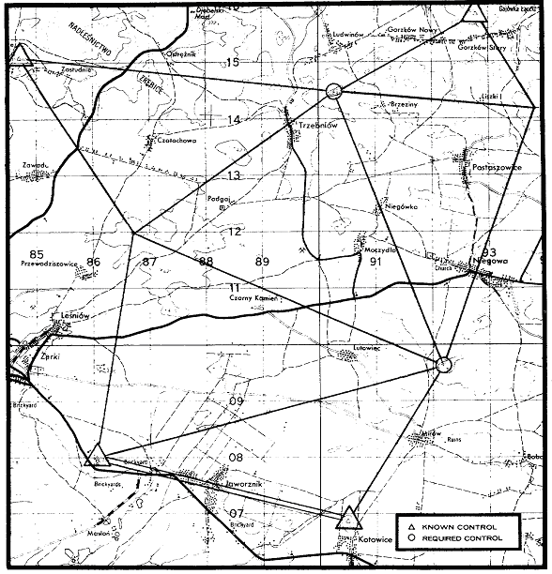
Figure 12. Known and proposed survey control
b. Perform Ground Reconnaissance. After you have determined reconnaissance, assemble your survey personnel. Brief them on your plan, and give the two instrument operators sketches of what angles they will measure. Load personnel and equipment and depart for the starting base. Remember, ground reconnaissance for triangulation will generally require as much time as the fieldwork; therefore, start the fieldwork as you continue the reconnaissance. Normally, the survey officer/NCO will take two or three surveyors along to erect targets over each station and to clear trees and underbrush, if required. The fieldwork for a triangulation scheme demands coordination. Therefore, the standing operating procedure (SOP) for your unit should contain a section on survey. When personnel become familiar with and employ standard signals, techniques, and procedures, they will accomplish their tasks in a minimum amount of time. Furthermore, the use of standard procedures reduces confusion and eliminates many errors, which expedites survey operation.
c. Sketch. After or during the ground reconnaissance, a sketch must be drawn of the triangulation scheme. The sketch must—
- Be drawn to scale.
- Contain a north grid index.
- Provide sufficient information to enable recovery or reconstruction of the fieldwork.
- Be recorded in the field notebook.
d. The Survey Order. In this example, the fieldwork started after the first two triangles were laid out. Therefore, you would brief the surveying party on the tactical situation and mission after the map reconnaissance or during the fieldwork. Detailed instructions on survey operations could be relayed by radio, messenger, or in person. Figure 13 illustrates the final survey plan.
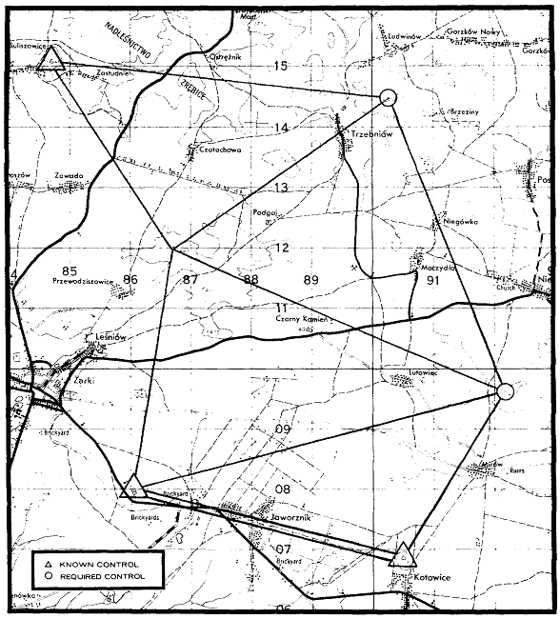
Figure 13. Final survey plan
14. SPECIFICATIONS AND TECHNIQUES. In traverse and triangulation, certain specifications and techniques are adhered to in fieldwork and computations to produce surveys of the desired accuracy. These specifications and techniques are shown in figures 14 and 15. Study these figures carefully.

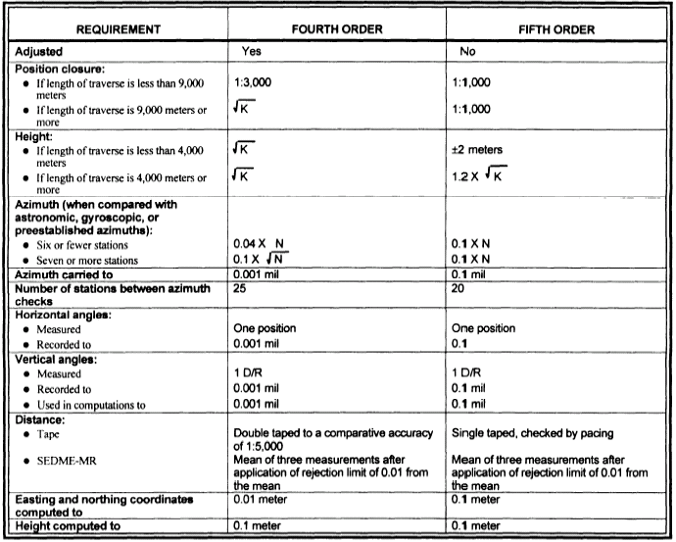
Figure 14. Traverse specifications

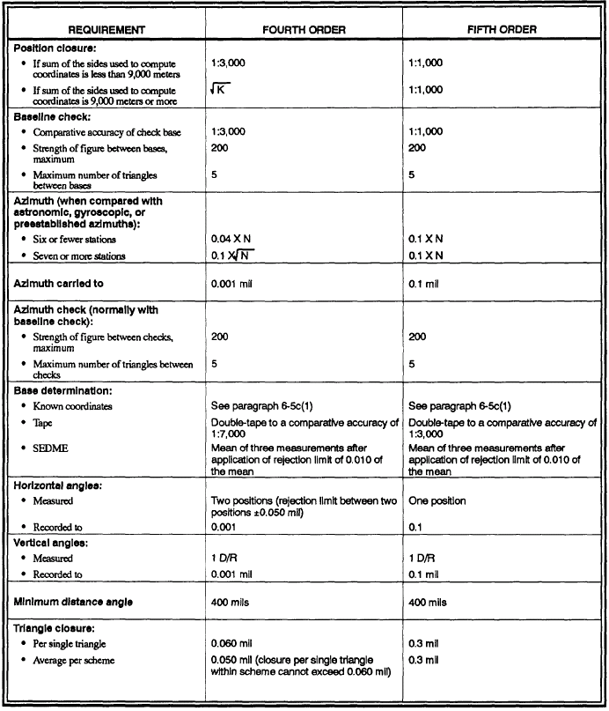
Figure 15. Triangulation specifications
15. SUMMARY. The traverse method is a rapid and flexible means of extending control. This method does not require as much time for reconnaissance as triangulation and is extremely easy to control in the field. It is ideally suited for survey in gently rolling or flat terrain or for extending control along roads and trails. Triangulation is a means of extending control over long distances in relatively short periods of time. It is ideally suited for survey in difficult terrain and for crossing over obstacles that cannot be taped or measured electronically. The primary disadvantage of triangulation is the amount of time required for reconnaissance. After evaluating all the factors that may affect a survey plan and the advantages and disadvantages of traverse and triangulation methods, the survey planning begins (see Para 5).
NOTE. | A fourth-order traverse or triangulation scheme must start and close on stations established to an accuracy of fourth order or higher.

LESSON 2
PRACTICE EXERCISE
Top of Form
Instructions | The following items will test your understanding of the material covered in this lesson. There is only one correct answer for each item. When you have completed the exercise, check your answers with the answer key that follows. If you answer any item incorrectly, review that part of the lesson that contains the portion involved.
1. | Traverse is a rapid and flexible means of extending control.
  A. True.
  B. False.

2. | For planning purposes, a well-trained traverse party using a 30-meter steel tape and taping techniques can extend control over open and gently rolling or flat terrain at a rate of approximately 2,000 meters per hour.
  A. True.
  B. False.

3. | The maximum allowable interior angle in a triangle is 2800 m.
  A. True.
  B. False.

4. | For planning purposes, triangulation requires approximately 30 minutes per station plus time for reconnaissance and travel between stations.
  A. True.
  B. False.

5. | Flexibility in triangulation schemes is more limited than in traverse schemes.
  A. True.
  B. False.

6. | The minimum allowable interior angle in a triangle is 400 m.
  A. True.
  B. False.

7. | Reconnaissance for triangulation will generally require as much time as the fieldwork.
  A. True.
  B. False.

8. | When the sum of the strength factors of a chain of single triangles exceeds 200 or at every fifth triangle, a check base (the required side) and azimuth must be determined.
  A. True.
  B. False.

ANSWER KEY
LESSON 2 PE
1. T (paragraph 10)
2. F (paragraph 10)
3. T (paragraph 13a (2))
4. T (paragraph 11)
5. T (paragraph 11)
6. T (paragraph 13a (2))
7. T (paragraph 11)
8. T (paragraph 13a (2))

LESSON 3
PLAN A THREE-POINT RESECTION AND AN ASTRONOMIC OBSERVATION
OBJECTIVE
Upon completion of this lesson you will be able to plan a three-point resection and an astronomic observation.
16. THREE-POINT RESECTION. Three-point resection is a method of survey used to obtain control for an unknown point on the basis of three inaccessible known points (fig 16).
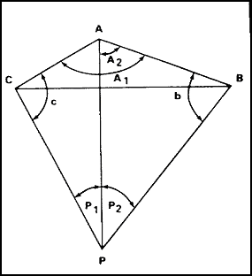
Figure 16. Three-point resection
a. Factors to Consider. Before the fieldwork is begun, several factors must be considered. In figure 16, points A, B, and C are the known points, and point P is the occupied station for which coordinates are to be determined. All points must be selected so that angles P1, P2, C, and B are at last 400 mils and preferably more than 533 mils. In addition, if the sum of the angles P1, P2, and A1 is between 2,845 and 3,555 mils, no valid solution is possible. This means that point P lies on or near a circle passing through stations A, B, and C. The final factor to consider is that points A, B, and C should be fourth order or higher.
b. Limitations and Use of Three-Point Resection. Unless a three-point resection has been checked by another three-point resection or some other method of survey, it should not be used as a point to extend survey control. Three-point resection could be used to locate a single point, to check a location determined by some other method of survey, or to verify points of suspected known control.
17. SITUATION THREE. The survey officer/NCO has returned from the commander's briefing on the next mission. He recorded the information pertinent to the situation (Para 5). Survey has the mission of establishing a fourth-order control point in the vicinity of grid coordinates 34UCB954011 on the ZARKI map. It is now 1000. You have until 1600 to complete the mission.
NOTE. | The survey party has one theodolite.
a. Perform a Map Reconnaissance. After attending the commander's briefing and issuing warning orders to his personnel, the survey officer/NCO performs a map reconnaissance. In performing a map reconnaissance, the survey officer/NCO uses the following procedures:
(1) Map spots installations. He plots on a map those installations requiring survey (fig 17). He also plots the known survey control in the area of operation.
(2) Selects a tentative plan. From plotting the known control, the survey officer/NCO notes that numerous churches in the area have known coordinates. This is an ideal situation to employ three-point resection. This is a fast method of survey and doesn't require much time for reconnaissance. All the churches are fourth order or better, and he realizes that he can close a three-point resection with another three-point resection. The survey officer/NCO constructs lines from the required survey station to the known points to check angles P1 and P2 (fig 17). Next, he constructs lines between known points to check angles C and B. After this, he adds angles P1, P2, and A1. All the specifications for three-point resection listed in subparagraph 16a are met (fig 18). Next comes the ground reconnaissance.
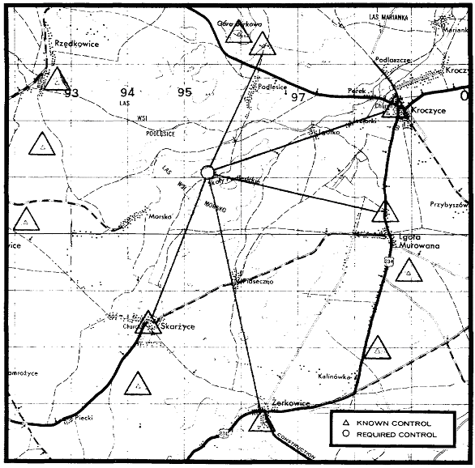
Figure 17. Known and required survey control
b. Ground Reconnaissance. After completion of the map reconnaissance, the survey officer/NCO issues instructions and departs for the station requiring survey. Upon arrival at the destination, he checks the line of sight between the station requiring survey and the known survey points. The tentative plan selected during the map reconnaissance is modified as required by terrain. The survey officer/NCO finalizes this plan and issues his orders (fig 18). Selecting a fourth known point and performing another three-point resection for point P can close this survey.
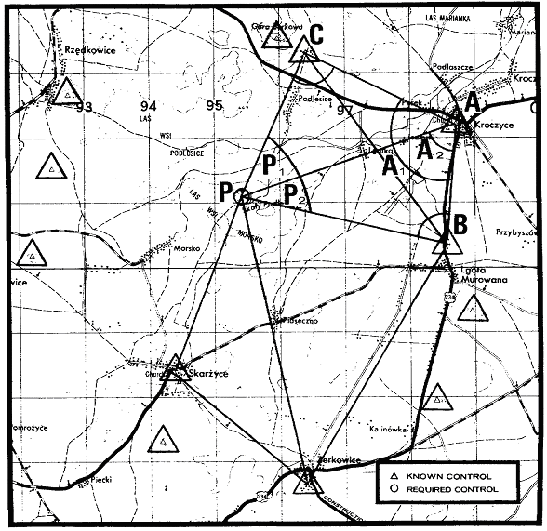
Figure 18. Final survey plan
18. ASTRONOMIC OBSERVATION. Weapon systems require an accurate direction from weapon to target. Providing the direction, or azimuth, is one of the primary missions of the artillery surveyor. Correct grid azimuth can be determined accurately, rapidly, and simply by the observation of the heavenly or celestial bodies (sun or star). These observations (astronomic observations) furnish true azimuth that can be easily converted to correct grid azimuth by applying grid convergence. Astronomic observations are made by the artillery surveyor to expedite the following survey operations:
- Determining or checking a starting azimuth for a survey.
- Checking the closing azimuth of a survey.
- Checking the azimuth of any line in a survey.
- Providing orienting azimuths for cannons and associated fire control equipment.
- Providing orienting azimuths for missiles and associated guidance equipment.
- Determining azimuths for declination of aiming circles.
19. METHODS OF DETERMINING ASTRONOMIC AZIMUTH. The artillery surveyor uses three basic methods to determine azimuth by astronomic observation—the altitude method, the arty astro method, and the Polaris tabular method. Each method will produce fourth- or fifth-order azimuth, depending upon the type of instrument used. All three methods require a horizontal angle from the azimuth mark to the celestial body in order to materialize the astronomic azimuth on the ground.

a. Altitude Method. The altitude method can be used to determine azimuth from the sun or from the stars. This method requires the solution of the astronomic (PZS) triangle by using, as determined data, the three sides of the triangle (polar distance, colatitude, and coaltitude). In the altitude method, the time is required only to determine the declination of the body. When the sun is observed, the time should be accurate within 5 minutes. For stars, only the date is required. Since time is not critical in the altitude method of observation, this method is used most frequently by artillery surveyors. To be suitable for the altitude method, the celestial bodies must—
  - Be between 175 and 800 mils in altitude (sun/star).
  - Be within 530 mils of the observer's prime vertical (sun/star).
  - Not be within 2 hours of the observer's meridian (sun).
NOTE. | The maximum altitude may be extended to 1,100 mils with special precautions on leveling the instrument between 800 and 1,100 mils. The altitude method is the only method of astronomic observation requiring a vertical angle and temperature reading. Temperature may be obtained from meteorological stations or a powder thermometer.

b. Arty Astro Method. The arty astro method may be used to determine azimuth from the sun or stars.

(1) Sun. The sun must not be within 1 hour of the observer's meridian. For best results, it should be above 175 mils in altitude. Unless an elbow telescope or the card method is used, the sun must be below 800 mils in altitude. Time must be accurate to the nearest 1 second.

(2) Stars. The arty astro method may be used with observations on Polaris or on east-west stars. Used with Polaris, this method yields the most accurate azimuths. For best results, stars should be between 175 and 800 mils in altitude. East-west stars must not be within 1 hour of the observer's meridian. Time must be accurate to the nearest 1 second for east-west stars and to the nearest 10 seconds for Polaris. Polaris may be observed any time it is visible, but best results are obtained when it is above 175 mils in altitude.

NOTE. | The hour-angle method is the only acceptable method for use with circumpolar stars.

c. Polaris Tabular Method. When time is of the essence and Polaris is observable, the observer can save time by using the Polaris tabular method. The only requirement for this method is that Polaris be visible and time accurate to within 1 minute.

20. SELECTION OF METHOD. Time of day, accuracy of time, and what azimuth accuracy is demanded determine the method to be used.

a. Fifth-Order Accuracy. Generally, speed of computations is the most important consideration when choosing a method for fifth-order astronomic azimuth determination.

(1) Night. At night, in the Northern Hemisphere, Polaris should always be used if it is observable, because it is easy to identify and easy to track. When observing Polaris, use either the arty astro method or the Polaris tabular method. If Polaris is not visible but an east-west star is, either the altitude method or the arty astro method can be used. If the star has a high star rate and accurate time is available, use the arty astro method. If the star has a low rate, the altitude method generally is preferable because it requires less accurate time than does the arty astro method. If time is not critical and only east-west stars are observable, observe a star in the east and one in the west.

(2) Day. In the daytime, use the sun-altitude method if the sun is in the proper position, since accurate time is not so important as it is with the arty astro method. If the sun is not in the proper position to use the altitude method, use the arty astro method.

b. Fourth-Order Accuracy. Generally, the prime consideration in choosing a method of fourth-order azimuth determination is accuracy. Theoretically, the arty astro method is more accurate than the altitude method, but this accuracy depends in turn on the availability of accurate time.

(1) Night. The best source of fourth-order accuracy is the Polaris arty astro method. (Polaris is never observed by the altitude method.) Polaris is easily identified and tracked, and when the arty astro method is used with Polaris, accurate time is not so critical as it is when used with an east-west body. The Polaris tabular method will yield reliable fourth-order azimuths. When Polaris cannot be seen, observe an east-west star with the arty astro method if accurate time is available. If time is unreliable, use the altitude method of observation.

(2) Day. In the daytime, use the arty astro method with the sun if accurate time is available; if not, use the altitude method.

21. CHOICE OF METHOD. The primary considerations in selecting a method of determining azimuth are—
- The time at the disposal of the observer.
- The instruments available for use.
- The correct time.
- The experience in astronomic observations.
- The degree of accuracy desired.
Refer to figures 19 and 20 for a comparison of methods for determining azimuths and the specifications for astronomic observations. Study these figures because some examination questions may come from them.

NOTE. | Time accurate to the second can be obtained from division artillery survey information center (SIC) or from the time signals broadcast by WWV, Fort Collins, Colorado, on 2.5, 5, 10, or 15 megahertz. (See TM 5-442 for a complete list of radio time signals.)
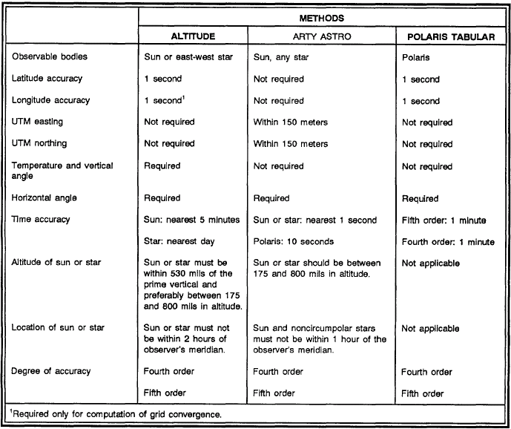

Figure 19. Comparison of methods

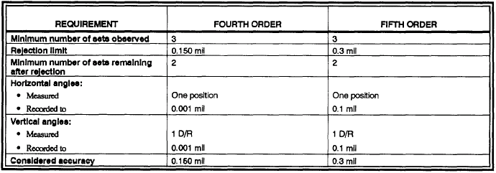

Figure 20. Astronomic specifications

22. SUMMARY.
a. Three-point section. Three-point resection is a fast and accurate survey method that is used to obtain control for an unknown point on the basis of three inaccessible known points (church steeples, water towers, smoke stacks, etc). This method requires very little time for ground reconnaissance. A thorough map reconnaissance will tell if the three-point resection is solvable. See the specifications for three-point resection (Para 16a). A point established by this method must be verified by another three-point resection or other means of survey before the point can be used to extend control. The fieldwork consists of measuring horizontal angles P1 and P2 (fig 16) and the vertical angle to either station A, B, or C, preferably point A. The horizontal angles are measured two positions and the vertical angle 1 D/R. Field notes are recorded in the same basic format as triangulation except that the height of instrument and height of target are recorded in the remarks section. Fourth- or fifth-order stations may be established by three-point resection if the specifications for triangulation are met (FM 6-2, annex B). The points (A, B, and C, fig 16) used for three-point resection should be fourth-order or higher. This method of survey is ideally suited for Europe because of the numerous survey stations that are inaccessible. Azimuth may be extended from a three-point resection if the azimuth has been verified by gyroscopic azimuth or astronomic azimuth.
b. Astronomic Observation. The artillery surveyor uses three basic methods to determine azimuth by astronomic observation—the altitude method, the arty astro method, and the Polaris tabular method. Each of these methods will produce fourth- or fifth-order azimuths. The best source of fourth-order accuracy is the Polaris arty astro method. However, since time is not critical, the altitude method is used most often by artillery surveyors. At night, in the northern hemisphere, Polaris should always be used if it is observable, because it is easy to track and easy to identify. When observing Polaris, use either the arty astro method or the Polaris tabular method. You cannot use the altitude method with Polaris. When planning astronomic observations, the position of celestial bodies is very important. (Review fig 19 and 20.)

LESSON 3
PRACTICE EXERCISE

Note: The following exercise is a study aid. Print this sheet and write your answer in the space provided below each question. When you have finished answering all the questions for this lesson, compare your answers with those given by following the link at the bottom of this page. Review the lesson as necessary.

Top of Form
1. | Three-point resection is a method of survey that is used to obtain control for an unknown point on the basis of three inaccessible known points.
  A. True.
  B. False.

2. | In three-point resection, angles P₁, P₂, C, and B must be at least _________ mils and preferably more than ________ mils.

3. | If the sum of angles P₁, P₂, and A₁ is between _________ mils and __________ mils, no valid solution is possible.

4. | In three-point resection, points _____, _____, and _____ should be fourth-order or higher.

5. | Unless a three-point resection has been checked by another three-point resection or some other method of survey, it should not be used to extend survey control.
  A. True.
  B. False.

6. | The best source of fourth-order accuracy is the ______ _____ _____ _____.

7. | The _____ _____ _____ is theoretically more accurate than the ______ ______.

8. | What method of astronomic observation requires a vertical angle and temperature reading?

9. | At night, in the northern hemisphere, Polaris should always be used if it is observable, because it is easy to identify and easy to track.
  A. True.
  B. False.

10. | When the sun is observed by use of the altitude method, the time should be accurate to within 7 minutes.
  A. True.
  B. False.

ANSWER KEY
LESSON 3 PE
1. T (paragraph 16)
2. 400, 533 (paragraph 16a)
3. 2,845 and 3,555 (paragraph 16a)
4. A, B, and C (paragraph 16a)
5. T (paragraph 16b)
6. Polaris arty astro method (paragraph 20b (1))
7. arty astro method, altitude method (paragraph 20b)
8. altitude method (paragraph 19a)
9. T (paragraph 20a (1))
10. F (paragraph 19a)

LESSON 4
SELECT POSITIONS FOR OBSERVATION POSTS AND PLAN A SIMULTANEOUS OBSERVATION
OBJECTIVE
Upon completion of this lesson, you will be able to select positions for observation posts (OP) and to plan a simultaneous observation.
23. TARGET AREA BASE. The requirements for establishing a target area base are to locate two or more OPs relative to each other that overlook the target area, to determine the azimuth and distance between the two, and to determine an azimuth to a visible azimuth mark for each. The OPs are designated O1, O2, etc. O1 is considered the control OP and is plotted on the firing chart. O1 may be on the left or right of the base, but it is always the OP that requires the least amount of fieldwork to establish its location.
a. Purpose of Base. The base is used to extend survey control to critical points in the target area such as registration points, restitution points, high-burst registrations, mean points of impact, and targets of opportunity.
b. Selection of Observation Posts. If possible, the distance between any two OPs should be sufficient to insure an apex angle of 300 mils at any of the critical points. If this is not possible, then the two OPs must be far enough apart to ensure, at a very minimum, an angle of 150 mils at any critical point in the target area (fig 21).
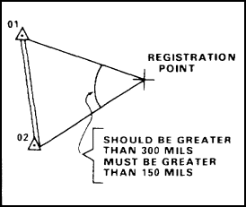
Figure 21. Minimum apex angles
c. Methods of Survey. The methods of survey normally used by the survey party in establishing the target area base are a closed traverse, triangulation, resection, or position and azimuth determining system (PADS). The base is established to fifth-order accuracy.
24. MISSION. The survey officer/NCO has returned from the commander's briefing. He alerts the survey party and starts gathering pertinent data. The survey mission is to select two OPs that will provide a good view of the area west of grid line 87, north of grid line 00, and south of grid line 05 (ZARKI map sheet). The OPs must be selected immediately. They must be far enough apart to ensure an apex angle of 300 mils or more (150 mils minimum) at any critical point.
25. MAP RECONNAISSANCE. Plot the area in which observation is to be conducted. This can be accomplished by drawing a heavy line around the target area (fig 22). Refer to your map of ZARKI, POLAND (enclosed with this subcourse), so that you can get a good view of the area in question. Figure 22 is a photographed portion of the ZARKI map, and some portions may be distorted.
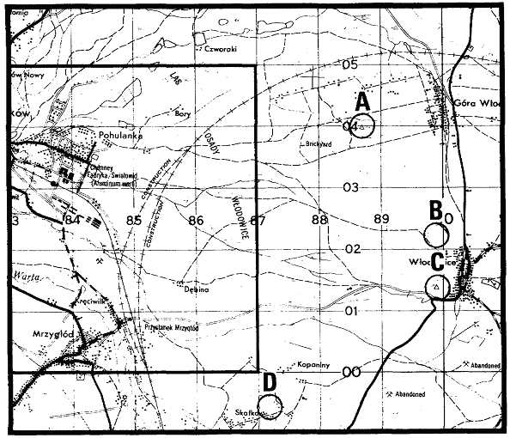
Figure 22. Target area and possible OP locations
a. Selecting Tentative Locations. Look for ideal positions that would give you a view of the whole target area or a major portion of it. Hills and ridges offer the best prospect, so study the terrain features.
b. Other Considerations. Selecting vantage points for visual observation into enemy territory are ideal, but other factors must be considered such as the following:
- Do the selected points offer cover and concealment for the observers?
- Do the selected points offer a covered route of approach?
- Do the points have access roads or trails?
- Do the points offer a good base for communications? Are there existing roads or trails for emplacing wire nets?
- Does the area have any known survey control points? Remember, you must run survey to the OPs and provide an azimuth.
26. GROUND RECONNAISSANCE. During the map reconnaissance, you have selected four points as potential OPs (fig 22 A, B, C, and D). Of the four potential OPs, you have decided that points A and C come the closest to the standards discussed; therefore, you reconnoiter these areas first. Brief the survey party on your plan, and depart for points A and C.

NOTE. | You have picked vantage points for visual observation into enemy territory. This means the enemy can see you; therefore, it is imperative that you use cover and concealment when approaching the potential OPs.

Upon arrival at points A and C, there are several things that must be considered when selecting the site for the actual OPs.
- Do the OPs have a good view of the target area?
- Does the distance between OPs ensure an apex angle of 300 mils (150 mils minimum) to all critical points?
- Do the positions provide cover and concealment for the observers?
- Will it be easy to install a wire net?
- Are the OPs intervisible?
- Is it possible to put the OPs on the forward (west) slope of the hill?
- Is there known survey control within the area?
If you can say yes to the above questions, you have an ideal site. Normally, you will never find a site that is ideal. Points B and D (fig 22) were not used in this example, but it is possible that they could be used as alternate OPs.

NOTE. | No OP is good if the enemy knows its location. Therefore, be extremely cautious when occupying OPs. There is no substitute for cover and concealment. Usually, the best location for an OP is on or near the military crest of a hill. The topographical crest should be avoided because of the possibility of being skylined.

27. SKETCH. After the sites are selected, draw a sketch of the area. Include information such as access roads and trails, prominent targets, azimuth marks, and terrain features. The survey officer/NCO finalizes his plan and issues his orders.

28. SURVEY ORDER. See FM 6-2, chapter 15.

29. SIMULTANEOUS OBSERVATION. The purpose of survey is to place target acquisition equipment, firing units, observation posts, and targets on a common grid system. In the offense, however, especially on a highly mobile and fluid battlefield, survey control may be restricted to the barest essentials, starting with the fundamental requirement—direction. Simultaneous observation of a celestial body provides a rapid method of transmitting direction over great distances without time-consuming computations(fig 23). This method is ideally suited to the needs of the artillery, since many units can be placed on a common directional control in a very short period of time. Because of the great distances of celestial bodies from the earth, the directions to a celestial body at any instant from two or more close points on the earth are approximately equal. The difference between the azimuths is due primarily to the fact that the azimuths at different points are measured with respect to different horizontal planes. This difference can be determined by use of the nomograph (fig 24).

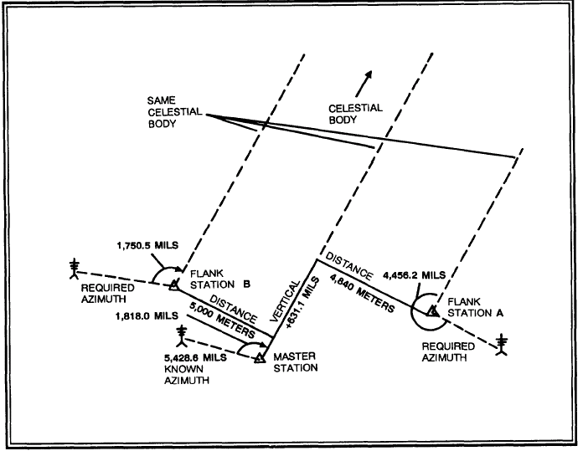

Figure 23. Simultaneous observation
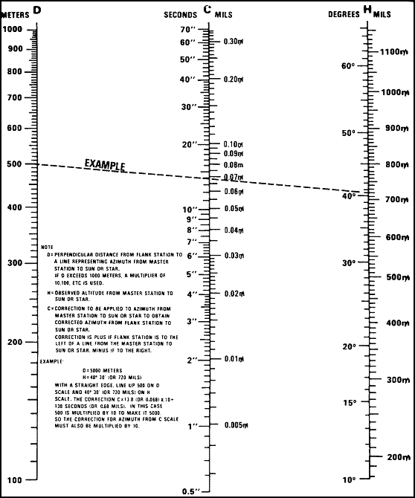

Figure 24. Nomograph

a. Requirement. Flank stations are established at points where an azimuth is needed. A master station is established at a point from which the azimuth (an assumed azimuth may be used) to an azimuth mark is known or can be computed. Both the flank and master stations should be points that are easily identified on a map and that provide the best possible communications. A prominent celestial body (sun, moon, or star) is selected by the master station and identified to the observer at the flank stations. Also, the master station will determine the starting time for observation.

b. Mission. You are at the road intersection at coordinates 34UDB016197 on the ZARKI map sheet. You receive a radio call from the battalion XO saying that he needs azimuth control at coordinates 34UDB035220, 34UDB045185, and 34UCB993205. Firing battery personnel will be set up at these locations and will be ready to observe at 1400 today. The firing batteries will switch their radio channel to the battalion survey net at 1355. It is now 1200.

- Map Reconnaissance. Plot the installations desiring directional control (fig 25). Also, plot the known control within the area of operation. There is known survey control close to your location (fig 25). The rolling terrain should provide good radio communication between the master and the flank stations. The church steeple (coordinates 34UDB015197) will be the azimuth mark. The survey party is alerted.

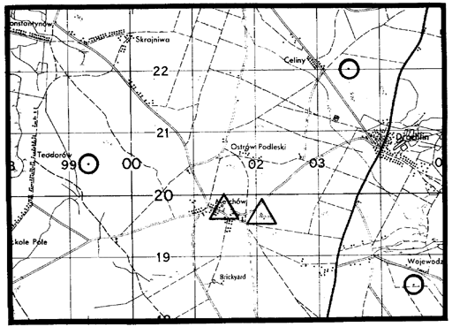

Figure 25. Known control and desired direction.

d. Ground Reconnaissance. After the tentative plan is made during the map reconnaissance, the survey officer/NCO makes a ground reconnaissance to locate the known survey station. Also, he notes that a line of sight does exist to the church steeple (azimuth mark). The survey plan is finalized, and the survey officer/NCO issues his orders.

e. Fieldwork. The survey officer/NCO contacts the firing batteries at 1355. He informs them that the celestial body will be the sun and tracking will start at 1405. After the simultaneous observations are completed, the master station sends the following information to the flank stations: the grid coordinates of the master station, the vertical angle to the sun, and the grid azimuth from the master station to the sun. The flank stations do the plotting and computations.

NOTE: | If you take more than one set of observations, the azimuth to the sun and the vertical angle to the sun for each set will be reported to the flank stations.

30. SUMMARY. Artillery cannot destroy targets unless they know the target location; therefore, it is imperative that a target area base be selected that provides vantage points for visual observation into enemy territory. The base (distance between any two OPs) should be sufficient to ensure an apex angle of 300 mils or more at any of the critical points. The minimum allowable apex angle is 150 mils. The position selected should provide cover and concealment plus a covered route of approach. Also, the OPs should be close to survey control (if possible) to facilitate survey operations. In the offense, especially on a highly mobile battlefield, survey control may be restricted to the barest essentials, starting with the fundamental requirement—direction. Simultaneous observation is a rapid method of transmitting direction over great distances. Upon command, the survey party establishes a master station. The master station controls the operation and selects the celestial body. Any station desiring direction is known as a flank station. The procedure for simultaneous observation is simple, easy, and accurate. It can be used day or night, providing a celestial body is visible to all stations.

LESSON 4
PRACTICE EXERCISE
Top of Form
Instructions | The following items will test your understanding of the material covered in this lesson. There is only one correct answer for each item. When you have completed the exercise, check your answers with the answer key that follows. If you answer any item incorrectly, review that part of the lesson that contains the portion involved.
1. | OP1 is the control OP. It can be on the left or right, facing the target area.
  A. True.
  B. False.

2. | The distance between any two OPs should be sufficient to ensure an apex angle of 300 mils at any of the critical points in the target area.
  A. True.
  B. False.

3. | The minimum apex angle allowable for any of the critical points in the target area is 175 mils.
  A. True.
  B. False.

4. | The OPs selected should give a view of the whole or a major portion of the target area.
  A. True.
  B. False.

5. | Cover and concealment must be strictly enforced when you occupy and operate the OPs.
  A. True.
  B. False.

6. | Simultaneous observation provides a rapid method for transmitting direction over a great distance.
  A. True.
  B. False.

7. | In simultaneous observation, what information must be transmitted from the master station to the flank station(s)?
  A. Grid coordinates of the master station.
  B. Altitude of the master station.
  C. Vertical angle from the master station to the celestial body.
  D. Azimuth from the master station to the celestial body.

8. | Communication is a must between the master and flank station(s).
  A. True.
  B. False.

ANSWER KEY

LESSON 4 PE

1. T (paragraph 23)

2. T (paragraph 23b)

3. F (paragraph 23b)

4. T (paragraph 25a)

5. T (paragraph 26)

6. T (paragraph 29)

7. a, c, and d (paragraph 29e)

8. T (paragraph 29)

